**DÉCOR LIGHT**

Find a variety of styles, materials, and features to suit your light

# LED LIGHT

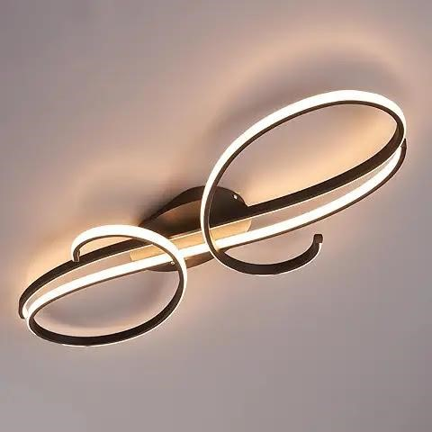

Description:

Ceiling Led Light

Garwarm Modern Ceiling Light, 23.6”

Ceiling plate: 9.4 inches,

Power: 60W, 4800lm,

Voltage: 110V,

Color temperature: 3000K-6500K

**Cannot used with dimmer switch**

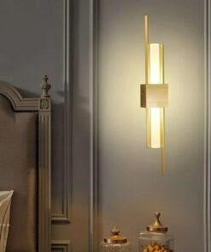

Description:

## Led wall light

Depth (from the wall to light): 4.4 cm (1.7 inches) Height: 55 cm (21.7 inches) Light Color: Warm White

### Excellent Performance with abundant illumination

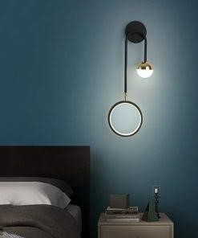

Description:

Led wall Light

Depth (from the wall to light): 4.4 cm (1.7 inches)

Height: 55 cm (21.7 inches)

Light Color: Warm White

### Excellent Performance with abundant illumination

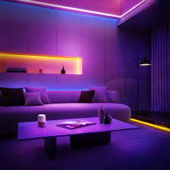

Description:

Neon light

Led wall Light

Depth (from the wall to light): 4.4 cm (1.7 inches)

Height: 55 cm (21.7 inches)

Light Color: Warm White

Excellent Performance with abundant illumination

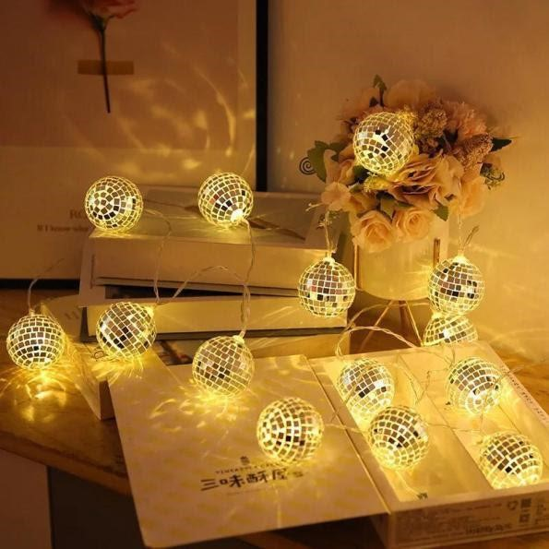

# • Led Light

**Description:**

## Battery ball F-light

Material: Plastic, Copper Wire

LED quantity: 10-20 pieces

Input Voltage: 4.5V

Power: 3pcs AA battery box (Not included battery)

The space of bulb: 10cm / 3.93 inch

Total length: 230cm / 90.55 inch

The color of the wire: transparent wire

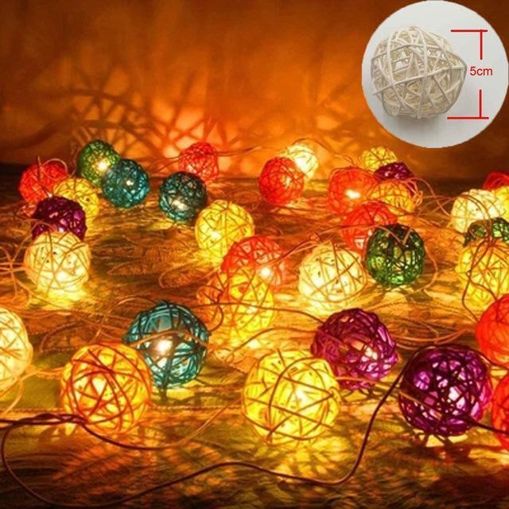

**Description:**

Christmas ball light

Material: Plastic, Copper Wire

LED quantity: 10-20 pieces

Input Voltage: 4.5V

Power: 3pcs AA battery box (Not included battery)

The space of bulb: 10cm / 3.93 inch

Total length: 230cm / 90.55 inch

The color of the wire: transparent wire

**A warm and romantic atmosphere with these warm white LED lights**

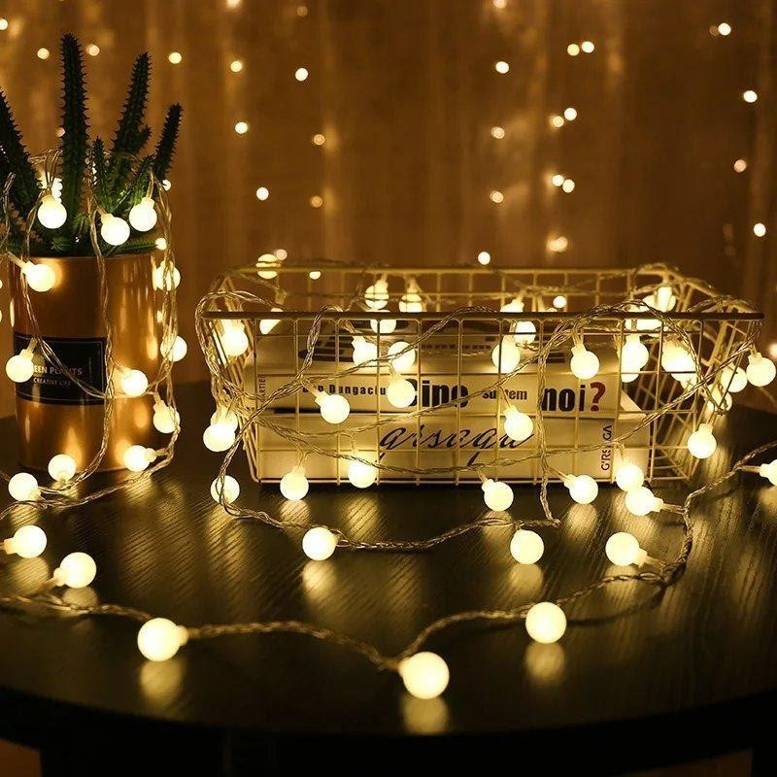

**Description:**

## Ball Light

Shape: round ball

Ball color: white

Light color: warm white

Cable Color: Transparent

Number of LEDs: 10/20/30

### Power supply: USB direct plug

**Note: This is not completely waterproof, in order to maintain a long service life, please avoid rain or wet environment.**

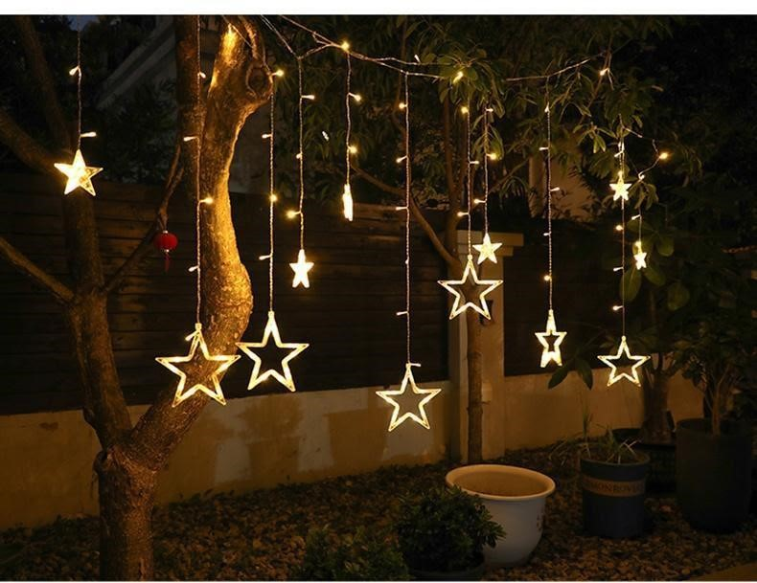

**Description:**

## Star Curtain light

Color: Warm White

Brand: Quntis

Product dimension: 20 x 20 x 11cm; 558grams

Date Firs available: 7 may 2023

IP44 Waterproof &Safe to Touch

8 Flashing Modes & Memory Function

**Shining and Charming to Accompany Your**

**Christmas**